**Vanier College**

**Faculty of Science and Technology System** **Development**

**420-541-VA**

**FUMG**

**User Guide**

**Dimitriu Jonathan**

**Patel Dinal**

**Balibalos Craig Justin**

**Table of Content**

What is FUMG? 2

The Main Menu screen 3

The tutorial Screen 4

The Game Screen 5

# What is FUMG?

Firefighter’s Unknown Monster Grounds (FUMG) is a king of the hill type of game that as a firefighter, you must defend your town against the hellbringers, a humanoid fire monster that is trying to burn the whole town to ashes in order to claim the place.

# The Main Menu screen

On the main menu screen, you will be presented with 3 options, one to quit the game, to start the game which will bring to a city map and a tutorial map in which we would recommend starting to get the feel of the game.

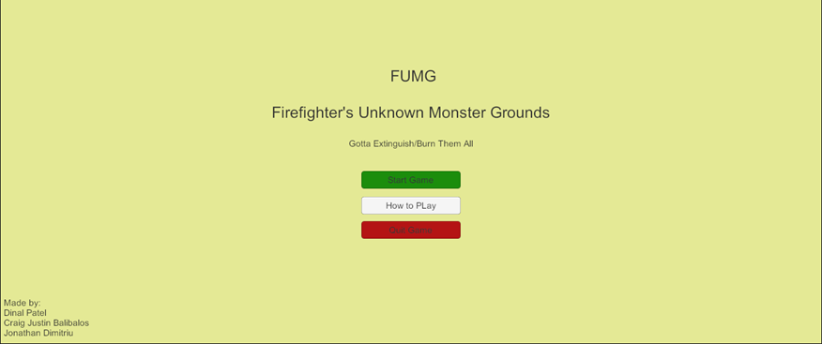

# The tutorial Screen

The tutorial screen will only introduce to the controls and how the objective works and the enemy to expect. If you would like to leave the tutorial screen, you need to press either the ESC button or the “B” key. This game works with the gamepad as well. To shoot with gamepad it is the right trigger. For testing purpose, The Q key button is used to shoot as an enemy projectile.

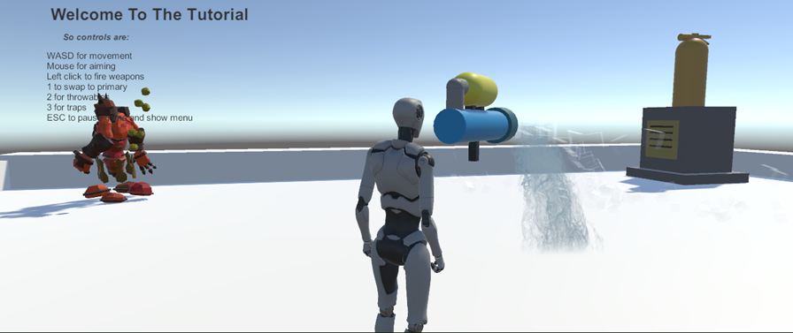

# The Game Screen

When you start the game, you will have to find the objective to defend. The goal of the objective in this map is to capture the area by shooting a fire extinguisher statue. However, you have the Hellbringers that will do the same and you must fend off against it. Once the fire extinguisher turns blue, you will need to defend it until your points reach 100. Once you reach 100, you will be presented with an end screen, and you can choose to either replay or head back to the main menu.

